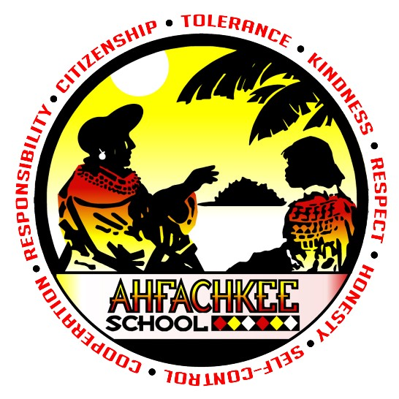
Ahfachkee School

Guidance Department Newsletter

January 2025

Dear Parents and Guardians,
Welcome back to Quarter 3, the start of Semester 2 and 2025, a brand-new year!

During first semester we added several new “firsts” in order to continue servicing your students in the most efficient and effective manner possible. We are happy with the addition of the “Ahfachkee Voice” suggestion boxes. You can find the two locations: in the media center and the other in the gymnasium hallway. This is another means of communication for our students.

Also, this first semester we celebrated Red Ribbon week in October and also added SEL Social Emotional Learning programs for both the middle and high school grade levels. These programs are implemented to promote emotional intelligence, develop skills for managing emotions and enhance personal development.

We would also like to remind you that your students’ current counselor will continue to progress with them throughout their academic years. We have done this in order to maintain the relationships established from their elementary years, allowing students to further grow academically. Mr. Osborn is assigned to those students with the last names beginning with A – J and Ms. Murgueytio is assigned to the students with the last names beginning K – Z.

During second semester we will continue to meet with all elementary and middle school classes to present the Character Trait of the Month. Additionally, we will be meeting with our Freshmen students to review their first and newly acquired GPA’s and address any high school questions they may have.

Finally, we are looking forward to hosting our yearly Career Day Event. This brings our school and community together by making positive connections for the future of our students.

For more information or if you have any questions, please be sure to contact us.

Let’s make this a terrific year with wonderful and fulfilling results!

